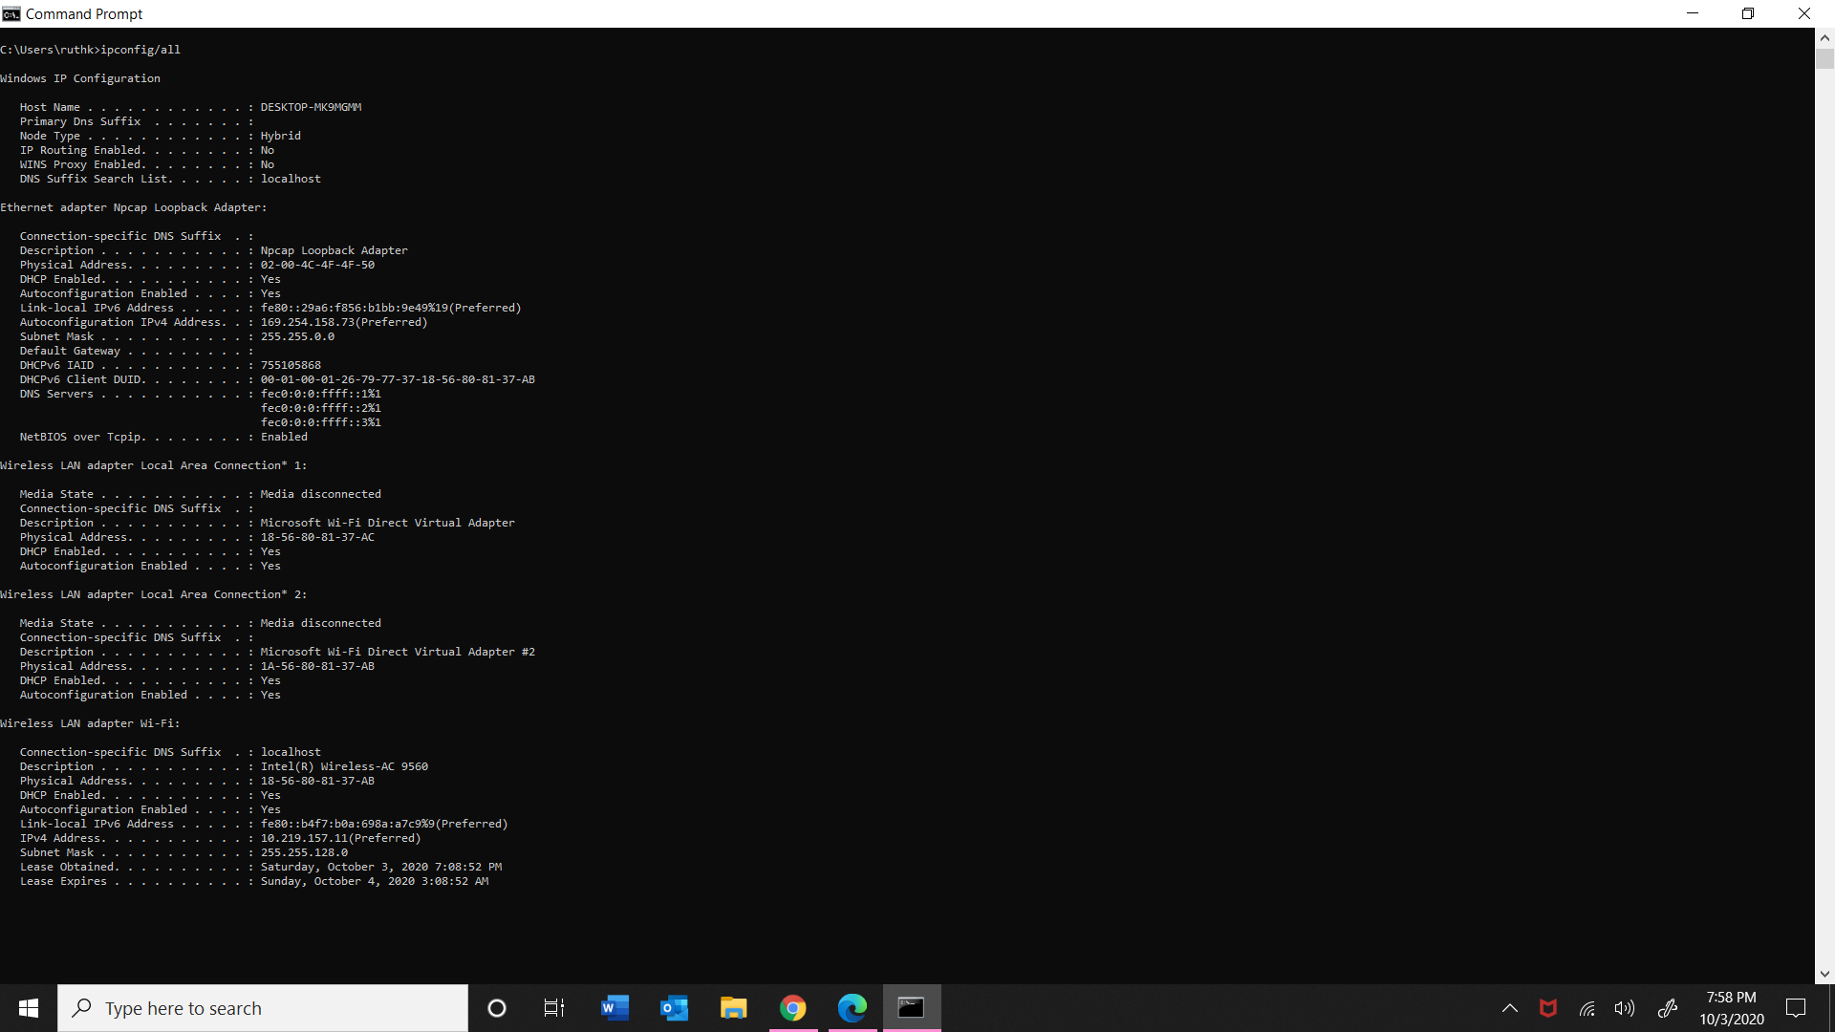

IP address: 10.219.157.11

Subnet Mask: 255.255.128.0

Default Gateway: 10.219.128.1

DHPC Server: 64.189.192.53

DNS Server: 66.28.0.45

Physical Address: 18-56-80-81-37-AB

Lease Obtained: Saturday, October 3, 2020 7:08:52 PM

Additional information

Subnets: Are designed to divide the network into logical pieces. The Subnet Mask enables computers to determine which other computers are on the same Subnet.

DHPC (Dynamic Host Configuration Protocol): It is a server protocol using UDP. And deals with unique IP Addresses

DNS (Domain Name Service): Have database to store internet addresses and IP.